School Counseling Program Newsletter
Shandrai Silva, School Counselor | November 2018
Counselor Message  Happy Thanksgiving. We have a lot to be grateful for at Hawks Nest. During October, the school counseling program facilitated Red Ribbon Week activities: spirit week, guidance lessons and door decorating contest. Congratulations to our Red Ribbon Door Decorating Contest winners: Ms. Patz for grades 3-5 and both Ms. Blake & Ms. Avery for Kindergarten – 2nd grades. HNSA also participated in Unity Day. In classroom guidance, students engaged in lessons about Bullying Prevention, Making Healthy Choices, Social- Emotional Learning, and Digital Citizenship.  In November, the school counseling program will continue with classroom guidance lessons on social-emotional learning, kindness, respect and digital citizenship. Small group are starting this month as well. And we’re participating in a school-wide service project this month.  We’re looking forward to all the great thing planned. Please feel free to contact me with any feedback you may have about the school counseling program.  How to see the school counselor  Classroom guidance classes, are based on grade  level specials schedule, Small group counseling  and individual counseling by self -referral, parent  referral, teacher referral, administrator referral  or counselor initiated.  Contact School Counselor at 704-866-8467or sosilva@gaston.k12.nc.us. | Home of the Hawks  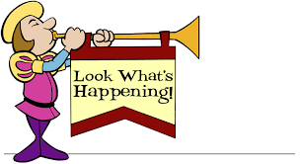  World Kindness Day  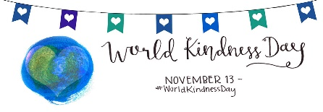  Hawks Nest STEAM Academy is collecting canned goods, socks and gloves to donate to local helping organization in recognition of World Kindness Day on November 13th.  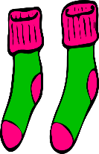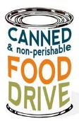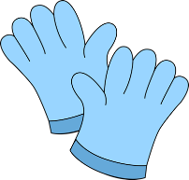  November 5 – 16, 2018   | Promoting Character Education  “We’re Soaring with Good Character”  ______________________________  The character trait of the month is Respect. Respect is taking turns, sharing, and listening to what others have to say; treating others respectfully.  ______________________________________  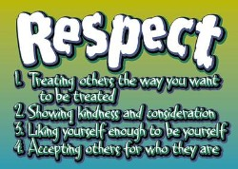  Problem- Solving for Kids  Here is what one mom used to teach her kids to problem solve as a coping strategy.  She created a chart with the following information and offers it as a free download. Read her post about the chart and how to use it.  Four Ways to Cope  - Say “Would you please stop (name the behavior)?”  - Ignore their behavior.  - Walk away.  - Get help.  https://thisreadingmama.com/coping-strategies-problem-solving-chart-kids/

